“Linux System Information and Resource Monitoring Tool”
A Project Report Submitted in the partial fulfillment of the requirements for the award of the degree of

BACHELOR OF TECHNOLOGY
In

DEPARTMENT OF COMPUTER SCIENCE ENGINNERING

By

P. HARINI 2520030177

AASRITHA 2520030178

P. BINDHU MADHAVI 2520030077

Under the Esteemed Guidance of

Dr. K. Hema
Assistant Professor
Department of Computer Science and Engineering




K L (Deemed to be) University DEPARTMENT OF COMPUTER SCIENCE ENGINEERING
&

DEPARTMENT OF COMPUTER SCIENCE AND INFORMATION TECHNOL

Declaration

The Project Report entitled “Linux System Information and Resource Monitoring Tool” is a record of Bonafide work of P. HARINI - 2520030177, AASRITHA - 2520030178, P. BINDHU MADHAVI - 2520030077 submitted in
partial fulfillment for the award of B. Tech in Computer Science and Engineering (or) Computer Science and Information Technology to the K L University. The results embodied in this report have not been copied from any other departments/University/Institute.

P. HARINI 2520030177

K.AASRITHA 2520030178

P. BINDHU MADHAVI 2520030077

K L (Deemed to be) University

DEPARTMENT OF COMPUTER SCIENCE ENGINEERING

CERTIFICATE

This is to certify that the mini project based report entitled “Linux System Information and Resource Monitoring Tool” is a bonafide work done and submitted by P. HARINI - 2520030177, AASRITHA - 2520030178, P. BINDHU MADHAVI - 2520030077
in partial fulfillment of the requirements for the award of the degree of BACHELOR OF TECHNOLOGY in Department of Computer Science Engineering, K L (Deemed to be University), during the academic year 2026-2027.

Signature of the Guide

Signature of the Course Coordinator Signature of the HOD
DR
ACKNOWLEDGEMENT
The success in this project would not have been possible but for the timely help and guidance rendered by many people. Our wish to express my sincere thanks to all those who has assisted us in one way or the other for the completion of my project.

Our greatest appreciation to my Course Coordinator Dr. K. Anusha, and my guide Dr. K. Hema , Department of Computer Science which cannot be expressed in words for his/her tremendous support, encouragement and guidance for this project.

We express our gratitude to Dr. P Venkateshwara Roa (CSE), Head of the Department for Computer Science Engineering for providing us with adequate facilities, ways and means by which we are able to complete this project-based Lab.

We thank all the members of teaching and non-teaching staff members, and also who have assisted me directly or indirectly for successful completion of this project. Finally, I sincerely thank my parents, friends and classmates for their kind help and cooperation during my work.

P. HARINI 2520030177

K.AASRITHA 2520030178

P. BINDHU MADHAVI 2520030077
Abstract

A Linux system may run a large number of processes at the same time, which makes it difficult to observe system activity and resource usage manually. Users normally have to run several separate commands to see CPU, memory, disk and process details. To address this, our project focuses on the design and development of the Linux System Information and Resource Monitoring Tool, a system programming project developed in the C programming language on Ubuntu/Linux. The tool monitors important operating system resources and running processes and presents the collected information through a simple command-line interface.

The tool provides system-level information including CPU details, overall CPU usage, memory usage, disk usage and system uptime. It scans the Linux /proc filesystem to obtain process information such as process ID, process name, process state and process memory usage. Users can configure a CPU threshold (compared with overall CPU usage) and a memory threshold (compared with the memory used by each process), and the system generates a warning whenever a configured limit is exceeded. Selected processes can be controlled using their PID with Linux signals: SIGSTOP to stop, SIGCONT to continue and SIGTERM to terminate a process.

The project follows a client-server approach using TCP socket communication on port 8080, where the client provides the menu-driven user interface and the server performs the monitoring operations. Detailed listings are printed on the server terminal, while the client receives a short status message. A POSIX thread supports continuous monitoring, tracking newly created and terminated processes along with CPU and memory warnings. Important monitoring activities and user operations are stored in the log file logs/monitor.log for future reference. In summary, the project demonstrates practical Linux and Operating Systems concepts including /proc filesystem handling, process monitoring, signals, file I/O, threads, sockets and system resource management.

Index

S. No. | Chapter | Topics / Subtopics | Page No.
 | Acknowledgement |  | i
 | Abstract |  | ii
1 | Introduction |  | 8–9
 |  | 1.1 Background of the Project
 |  | 1.2 Problem Statement
 |  | 1.3 Scope of the Project
 |  | 1.4 Objectives of the Project
 |  | 1.5 Importance of the Application
 |  | 1.6 Target Users / Audience
2 | OS Concepts and Background Study |  | 10–11
 |  | 2.1 Operating System Concepts Related to the Project
 |  | 2.2 Existing Methods / Algorithms
 |  | 2.3 Proposed Approach
 |  | 2.4 Advantages of the Proposed Approach
3 | System Requirements |  | 12
 |  | 3.1 Hardware Requirements
 |  | 3.2 Software Requirements
 |  | 3.3 Operating System Environment – Ubuntu / WSL
 |  | 3.4 Development Tools and Compilers
4 | Technology and Tools Used |  | 13–14
 |  | 4.1 C / C++ Programming
 |  | 4.2 GCC Compiler
 |  | 4.3 Linux System Calls
 |  | 4.4 POSIX Threads / Synchronization
 |  | 4.5 Linux Commands and Utilities
 |  | 4.6 Other Tools / Libraries Used
5 | System Architecture and Design |  | 15–17
 |  | 5.1 Overall System Architecture
 |  | 5.2System Workflow
 |  | 5.3 Flowchart / Data Flow
 |  | 5.4 Module Description
 |  | 5.5 Input and Output Design
6 | Implementation |  | 18–21
 |  | 6.1 Module-wise Implementation
 |  | 6.2 Algorithm / Pseudocode
 |  | 6.3 Core C / C++ Implementation
 |  | 6.4 Linux System Calls / APIs Used
 |  | 6.5 Process / Thread Implementation
 |  | 6.6 IPC / Synchronization Implementation
 |  | 6.7 Memory Management Implementation
 |  | 6.8 Optional User Interface Implementation
7 | Execution and Demonstration |  | 22–34
 |  | 7.1 Compilation in Ubuntu
 |  | 7.2 Execution Commands
 |  | 7.3 Sample Inputs and Outputs
 |  | 7.4 Screenshots of Execution
 |  | 7.5 Demonstration of OS Concepts
8 | Conclusion |  | 35–36
 |  | 8.1 Summary of the Project
 |  | 8.2 Objectives Achieved
 |  | 8.3 Results Achieved
 |  | 8.4 Skills and Learning Outcomes
9 | References |  | 37
 |  | 9.1 Books
 |  | 9.2 Research Papers
 |  | 9.3 Linux / GNU Documentation
 |  | 9.4 Online Resources

CHAPTER -1 INTRODUCTION

1.1 Background of the Project
A Linux system runs a large number of processes at the same time. Each process uses CPU time and memory, changes its state during execution, and may be created or terminated at any moment. The Linux kernel exposes this live information to user programs through the /proc virtual filesystem, which contains files such as /proc/cpuinfo, /proc/meminfo, /proc/stat and a directory for every running process (/proc/[PID]).
Standard utilities such as top, ps, free, df and uptime display parts of this information, but the user has to run several tools separately. The Linux System Information and Resource Monitoring Tool is a C-based system programming project, developed on Ubuntu/Linux, that brings system information, process information, threshold warnings, process control and logging together in a single command-line tool.

1.2 Problem Statement
Because many processes run at once, it is difficult to observe system activity and resource usage manually. Processes may consume significant CPU or memory, remain active for a long time, or change state during operation. The user needs a simple mechanism to view system information and monitor running processes without repeatedly checking multiple Linux commands.
There is also a need to identify when configured CPU or memory limits are exceeded, to control a particular process using its process ID, to know which processes are newly created or terminated during monitoring, and to maintain a record of important activities. This project addresses these needs with a C-based monitoring tool that reads data directly from the /proc filesystem and other Linux interfaces.

1.3 Scope of the Project
The scope of the project covers the following:
- Display of CPU information, overall CPU usage, memory usage, disk usage and system uptime.
- Listing of running processes with process ID, process name, process state and memory usage.
- User-configurable thresholds (overall CPU usage in percent and per-process memory in MB) with warnings when a limit is exceeded.
- Process control (stop, continue, terminate) using Linux signals and the process ID.
- Continuous monitoring using a POSIX thread that tracks newly created and terminated processes.
- Logging of important monitoring events and user operations in a log file.
- Client-server operation over TCP sockets with a menu-driven command-line client.
The tool is intended for a single Linux host and is operated from the terminal; it does not provide a graphical interface. The server handles one client connection at a time, and per-process CPU percentage is not calculated in this version (processes are listed with their state and memory usage).

1.4 Objectives of the Project
- To monitor running Linux processes and their states.
- To collect and display CPU and memory usage information.
- To obtain system and process information from the Linux /proc filesystem.
- To display CPU details, disk usage and system uptime.
- To configure CPU and memory usage thresholds.
- To generate warnings when resource usage exceeds the configured thresholds.
- To provide process control using Linux signals.
- To stop, continue or terminate a selected process using its PID.
- To track newly created and terminated processes.
- To maintain logs of important monitoring activities.
- To provide continuous monitoring using POSIX threads.
- To provide client-server communication using TCP sockets.
- To provide a simple command-line interface for monitoring and managing the system.

1.5 Importance of the Application
The application shows how an operating system makes its internal state available to user programs and how that state can be used for monitoring and control. For users, it replaces repeated use of many separate commands with one interface. Threshold warnings help to notice abnormal resource usage early, signal-based control allows a misbehaving process to be paused or ended, and the log file gives a permanent record of what happened. For students, it is a practical demonstration of /proc handling, signals, threads, sockets and file I/O.

1.6 Target Users / Audience
- Students of Operating Systems and Systems Programming who want to see OS concepts working in a real program.
- System administrators who need a quick view of resource usage and process activity.
- Developers and testers who want to observe a program’s CPU and memory behaviour or pause and resume it.
- Linux learners who want to understand what the /proc filesystem contains.

CHAPTER -2 OS CONCEPTS AND BACKGROUND STUDY

2.1 Operating System Concepts Related to the Project
OS Concept | Description and use in this project
Process management | A process is a program in execution with its own PID, name and state (running, sleeping, stopped, zombie). The tool lists processes and reports these attributes.
/proc filesystem | A virtual filesystem maintained by the kernel. The tool reads /proc/cpuinfo, /proc/meminfo, /proc/stat, /proc/[PID]/stat and /proc/[PID]/status.
Signals | Software notifications sent to a process. SIGSTOP, SIGCONT and SIGTERM are sent with kill() to stop, continue or terminate a process.
System calls | The interface between user programs and the kernel, used for file access, sockets, signals and filesystem information.
File I/O | Used to read /proc files and to create and append to the monitoring log file.
Threads (POSIX) | A POSIX thread runs the continuous-monitoring loop (one cycle every 2 seconds) while the main thread continues to receive commands from the connected client.
Sockets (TCP) | Used for communication between the client and the monitoring server on port 8080.
Memory and CPU accounting | System memory figures come from /proc/meminfo (MemTotal and MemAvailable), per-process resident memory (VmRSS) from /proc/[PID]/status, and overall CPU usage from two readings of /proc/stat taken 0.5 seconds apart.
Filesystem information | statvfs() returns block counts and sizes, from which disk usage is calculated.

2.2 Existing Methods / Algorithms
Linux already offers command-line utilities for monitoring: top and htop (live process and CPU/memory view), ps (snapshot of processes), free (memory), df (disk usage), uptime (uptime and load) and kill (send signals). Their data comes from the same /proc interfaces.
The limitations for a user who wants an all-in-one solution are that each tool shows only a part of the picture, no single tool compares usage with user-defined CPU and memory limits and raises warnings, process creation and termination events are not reported together with resource data, and activities are not recorded in a single log file.

2.3 Proposed Approach
The proposed system is a client-server application written in C. The server collects system and process information from /proc and other Linux interfaces, checks thresholds, sends signals, runs the monitoring thread and writes the log. The client provides a menu-driven command-line interface, sends the user’s request to the server over a TCP connection and displays the server’s reply. The detailed output of system information, process information, resource checks and log viewing is printed on the server terminal, and the client receives a short confirmation. Continuous monitoring is performed by a POSIX thread that periodically compares the current process list with the previous one to detect newly created and terminated processes and also checks resource usage against the configured thresholds.

2.4 Advantages of the Proposed Approach
- Single tool for system information, process information, warnings, control and logging.
- Direct use of /proc and system interfaces, so no external libraries are needed.
- Separation of user interface (client) and monitoring logic (server) through TCP sockets.
- Continuous monitoring runs in a separate thread, so the client can still send commands (for example to stop the monitoring) while it is active.
- Persistent log file helps in later review of events and user operations.
- Simple menu-driven interface that is easy to learn and use.

CHAPTER -3 SYSTEM REQUIREMENTS

3.1 Hardware Requirements
Component | Requirement
Processor | Any modern x86-64 processor (dual-core or better recommended)
Memory (RAM) | 2 GB minimum, 4 GB recommended
Storage | About 100 MB of free disk space for source code, executables and logs
Display / Input | Standard monitor, keyboard and a terminal window
Network | Loopback (localhost) networking for client-server communication on port 8080

3.2 Software Requirements
Software | Purpose
Ubuntu / Linux | Operating system for development, testing and execution
GCC compiler | Compiling the C source code
make | Building the server and client using the Makefile
Linux terminal | Running the server and client and viewing output
Text editor / IDE | Writing the source code
Git and GitHub | Version control and submission of the project

3.3 Operating System Environment – Ubuntu / WSL
The project is developed and executed on Ubuntu/Linux because it depends on Linux-specific interfaces such as the /proc filesystem and Linux signal behaviour. It can be run on a native Ubuntu installation or in an Ubuntu virtual machine. Under Windows Subsystem for Linux (WSL), /proc is also available, although the values shown describe the WSL environment rather than the Windows host. The server listens on TCP port 8080 and the client connects to it from a second terminal.

3.4 Development Tools and Compilers
- GCC – compiles the C source files into the server and client executables.
- make – “make” builds the server and the client with gcc (-Wall -Wextra -std=c11, server linked with -pthread) and “make clean” removes the compiled executables.
- Linux terminal – two terminals are used, one for the server and one for the client.
- GitHub – stores the source code and documentation.

CHAPTER -4 TECHNOLOGY AND TOOLS USED

4.1 C / C++ Programming
The entire project is written in the C programming language. C gives direct access to POSIX and Linux system interfaces, which is essential for reading /proc, sending signals, creating threads and using sockets.

4.2 GCC Compiler
The GNU Compiler Collection (GCC) is used to compile the source code. A Makefile automates the build, producing the executables named server and client. Running make clean removes them.

4.3 Linux System Calls
System call / API | Use in the project
socket(), bind(), listen(), accept(), connect(), send(), recv() | TCP client-server communication
fopen(), fgets(), fprintf(), fclose() (stdio file functions) | Reading /proc files and writing the log file
kill() | Sending SIGSTOP, SIGCONT and SIGTERM to a process
statvfs() | Obtaining filesystem information to calculate disk usage
sysinfo() | Reading the system uptime
opendir(), readdir() | Scanning /proc to find running process IDs
usleep(), sleep() | 0.5 s CPU sampling delay and 2 s monitoring interval
pthread_create(), pthread_join() | Starting and joining the monitoring thread

4.4 POSIX Threads / Synchronization
POSIX threads (pthread library) are used to run the continuous monitoring activity in parallel with the server’s handling of client commands. Starting continuous monitoring (menu option 7) creates the monitoring thread with pthread_create(). Stopping it (option 8) clears the shared monitoring flag and calls pthread_join() so that the thread finishes its current cycle before the server replies. The flag is declared volatile and the server is linked with -pthread. This version does not use mutexes, so the thresholds and the stored process list are not locked; adding pthread mutexes is a planned improvement (see Section 8.3).

4.5 Linux Commands and Utilities
The following commands are used for building, running and cross-checking the tool’s output:
- make / make clean – build and clean the project.
- cd, ls, cat – navigating the project and viewing files such as /proc/meminfo and logs/monitor.log.
- ps, top, free, df, uptime – standard utilities used to verify the values displayed by the tool.

4.6 Other Tools / Libraries Used
No third-party libraries are required; the project uses only the C standard library and POSIX/Linux APIs. Git and GitHub are used for version control. The project repository is: https://github.com/pakalapatiharini/-Linux-Process-Resource-Monitoring-System

CHAPTER -5 SYSTEM ARCHITECTURE AND DESIGN

5.1 Overall System Architecture
The system follows a client-server architecture. The client is the user interface; the server performs all monitoring operations and communicates with the kernel through /proc and system calls. It serves one client connection at a time, and the monitoring thread exists only while continuous monitoring is running. Figure 5.1 shows the main components.
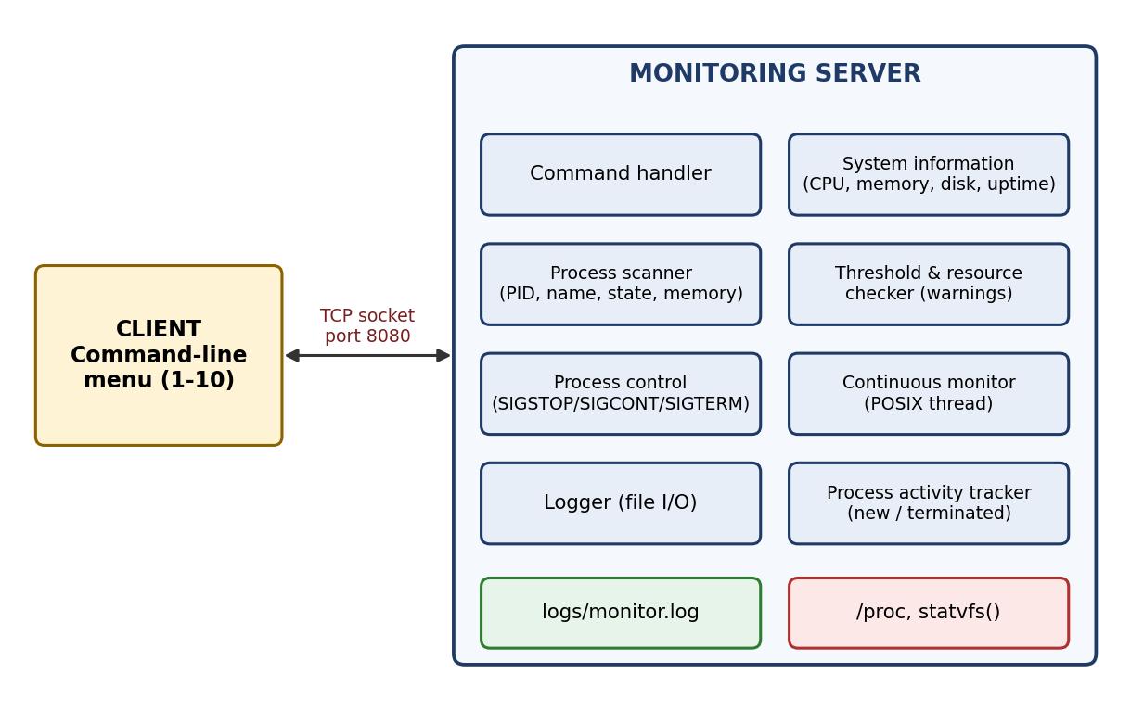
Figure 5.1 – Overall system architecture

5.2 System Workflow
Step 1: The server is started and begins listening on TCP port 8080.
Step 2: The client is started in a second terminal and connects to the server.
Step 3: The client displays the main menu with ten options.
Step 4: The user selects an option and, where needed, enters a value such as a threshold or a PID.
Step 5: The client sends the command to the server over the TCP connection.
Step 6: The server reads the required data from /proc or system calls, applies thresholds, sends signals or controls the monitoring thread.
Step 7: Important events and user operations are recorded in logs/monitor.log.
Step 8: The server sends a reply and the client displays it. For options 1, 2, 5 and 9 the detailed output (system information, process list, resource check, log contents) is printed on the server terminal and the client shows a one-line confirmation. The menu is shown again until the user chooses Exit; the server then closes the connection and waits for the next client.

5.3 Flowchart / Data Flow
The flow of control between the client and the server is shown in Figure 5.2.
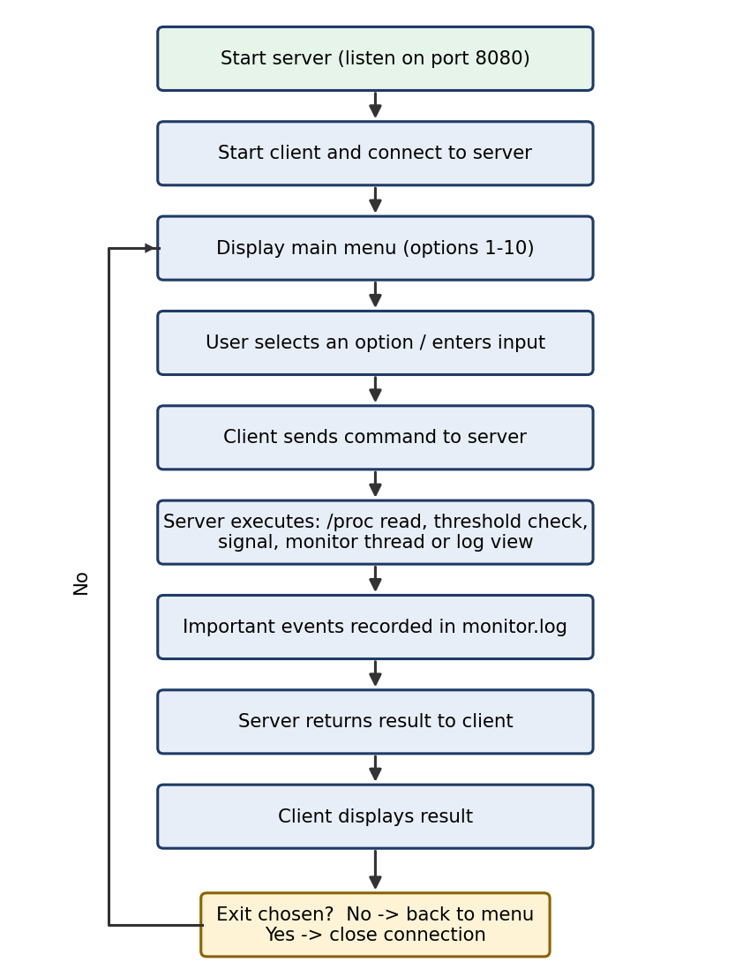
Figure 5.2 – Flowchart of client-server operation
Data flow: user input → client → TCP socket → server → /proc files and system calls → server processing (calculation, threshold comparison, signal) → TCP socket → client → reply shown to the user (detailed listings are printed on the server terminal). In parallel, the monitoring thread reads /proc every 2 seconds, prints its findings on the server terminal and writes events to the log file.

5.4 Module Description
Module | Description
System Information | Reads CPU details, overall CPU usage, memory usage, disk usage and uptime.
Process Information | Scans /proc and lists each process with PID, name (first 30 characters), state and memory usage in MB (up to 1024 processes).
Threshold Configuration | Stores the CPU threshold (default 80 %, limited to 0–100) and the memory threshold (default 512 MB) set by the user.
Resource Checking | Compares overall CPU usage with the CPU threshold and the memory used by each process with the memory threshold; prints a warning and logs it for every limit that is exceeded.
Process Control | Sends SIGSTOP, SIGCONT or SIGTERM to the process whose PID is given.
Continuous Monitoring | A POSIX thread that, every 2 seconds, reports newly created and terminated processes and runs the threshold check; can be started and stopped.
Logging | Writes timestamped events (threshold changes, successful process-control actions, monitoring start/stop, threshold warnings, process creation and termination) to logs/monitor.log; the log can be viewed from the menu.
Client-Server Communication | TCP sockets (port 8080) carry text commands (SYSTEM, PROCESS, SETCPU, SETMEM, CHECK, START, MONITORSTOP, LOGS, STOP/CONT/TERM <PID>, EXIT) from the client and status replies from the server.

5.5 Input and Output Design
The client presents the following menu. The user types the option number; options 3, 4 and 6 ask for additional input.
Option | Menu item | Input | Output
1 | System Information | – | Server terminal: CPU model, CPU usage, memory usage (%, used, total), disk usage, uptime in seconds, current thresholds; client shows a confirmation
2 | Process Information | – | Server terminal: list of processes with PID, name, state, memory usage and the total count; client shows a confirmation
3 | Set CPU Threshold | CPU threshold (1–100 %) | Client confirms “CPU threshold set to X%”; the change is logged
4 | Set Memory Threshold | Memory threshold in MB | Client confirms “Memory threshold set to X MB”; the change is logged
5 | Check Resources | – | Server terminal: current CPU usage against its threshold and a warning for each process above the memory threshold; warnings are logged
6 | Process Control | PID and action (stop / continue / terminate / back) | Success or error message (including the system error text) returned to the client
7 | Start Continuous Monitoring | – | Monitoring thread starts; new/terminated processes and warnings are printed on the server terminal
8 | Stop Continuous Monitoring | – | Monitoring thread stops
9 | View Logs | – | Contents of logs/monitor.log printed on the server terminal
10 | Exit | – | Client closes; the server closes the connection and waits for the next client

CHAPTER -6 IMPLEMENTATION

6.1 Module-wise Implementation
The work was divided among the team members as follows:
Roll No. | Student | Responsibility
2520030177 | P. Harini | Process control and signalling using SIGSTOP, SIGCONT and SIGTERM; TCP client-server communication; threshold monitoring; testing
2520030178 | Ashritha | Process log management; /proc data extraction; continuous monitoring; testing and integration
2520030077 | P. Bindhu Madhavi | System information; CPU and memory monitoring; process information; command-line interface

- System information: reads /proc/cpuinfo for CPU details, /proc/stat for CPU usage, /proc/meminfo for memory, statvfs() for disk usage and sysinfo() for the system uptime.
- Process information: scans /proc for numeric directories and reads /proc/[PID]/stat and /proc/[PID]/status for the name, state and memory usage (VmRSS) of each process. Per-process CPU percentage is not calculated in this version.
- Threshold and resource checking: keeps the CPU threshold (default 80 %) and the memory threshold (default 512 MB). Overall CPU usage is compared with the CPU threshold and the resident memory of every process with the memory threshold, producing a warning on violation.
- Process control: takes a PID and an action (STOP, CONT or TERM) and calls kill() with the matching signal; success is logged and a failure is reported with the system error text.
- Continuous monitoring: a POSIX thread rescans the process list every 2 seconds, compares it with the previous list to find new and terminated processes, and runs the threshold check.
- Logging: appends timestamped events to logs/monitor.log using file I/O; the logs directory must exist before the server is started.
- Networking: the server accepts the client’s TCP connection on port 8080, serves one client at a time, receives each command as a text string and sends back a reply; the client connects to 127.0.0.1.

6.2 Algorithm / Pseudocode
(a) Listing processes
open directory /proc
for each entry in /proc:
if the name is numeric (a PID):
read /proc/<PID>/stat and /proc/<PID>/status
extract name, state and memory usage
add to the output list
print the list on the server terminal and report its size

(b) Threshold check
read overall CPU usage (two /proc/stat samples 0.5 s apart)
if cpu_usage > cpu_threshold:
generate CPU warning and write it to the log
for each process whose memory (VmRSS, in MB) > mem_threshold:
generate memory warning for that PID and write it to the log

(c) Process control
receive the command (STOP, CONT or TERM) and the PID from the client
if action == STOP: signal = SIGSTOP
else if action == CONT: signal = SIGCONT
else if action == TERM: signal = SIGTERM
if kill(PID, signal) succeeds: report success, log the operation
else: report the error

(d) Continuous monitoring thread
previous = current list of PIDs (initialize_process_tracking)
while the monitoring flag is set:
current = current list of PIDs
PIDs in current but not in previous -> new processes (print and log)
PIDs in previous but not in current -> terminated processes (print and log)
previous = current
run the CPU and memory threshold check (print and log warnings)
sleep 2 seconds
(on Stop: the main thread clears the flag and calls pthread_join)

6.3 Core C / C++ Implementation
The complete source code (server.c, client.c, monitor.c, monitor.h, logger.c, logger.h and the Makefile) is available in the project GitHub repository (https://github.com/pakalapatiharini/-Linux-Process-Resource-Monitoring-System). The extracts below illustrate how the main APIs are used.
Sending a signal to a process:
if (kill(pid, SIGSTOP) == 0) { /* process stopped */ }
if (kill(pid, SIGCONT) == 0) { /* process continued */ }
if (kill(pid, SIGTERM) == 0) { /* process terminated */ }

Calculating disk usage with statvfs():
struct statvfs disk;
if (statvfs("/", &disk) == 0) {
unsigned long long total = (unsigned long long)disk.f_blocks * disk.f_frsize;
unsigned long long free_space = (unsigned long long)disk.f_bfree * disk.f_frsize;
double used_percent = 100.0 * (total - free_space) / total;
}

Starting the monitoring thread:
pthread_t monitoring_thread;
pthread_create(&monitoring_thread, NULL, monitoring_function, NULL);
Calculating overall CPU usage from /proc/stat:
total1 = get_total_cpu_ticks(); idle1 = get_idle_cpu_ticks();
usleep(500000); /* wait 0.5 s */
total2 = get_total_cpu_ticks(); idle2 = get_idle_cpu_ticks();
usage = (1.0 - (double)(idle2 - idle1) / (double)(total2 - total1)) * 100.0;

6.4 Linux System Calls / APIs Used
API | Purpose
/proc filesystem | Live system and process information
kill() with SIGSTOP, SIGCONT, SIGTERM | Process control
statvfs() | Disk usage
sysinfo() | System uptime
opendir(), readdir() | Scanning /proc for process IDs
usleep(), sleep() | 0.5 s CPU sampling delay and 2 s monitoring interval
TCP sockets | Client-server communication
POSIX threads – pthread_create(), pthread_join() | Continuous monitoring
File I/O | Reading /proc files and maintaining logs/monitor.log

6.5 Process / Thread Implementation
The server runs as one process. When continuous monitoring is started, a POSIX thread is created that performs periodic monitoring while the main part of the server continues to receive and handle commands from the connected client (one client at a time). The thread prints its findings on the server terminal and is joined with pthread_join() when monitoring is stopped or the server shuts down. Process states reported by the tool (for example running, sleeping or stopped) are read from /proc/[PID]/stat; after a SIGSTOP the target process is shown in the stopped state until SIGCONT is sent.

6.6 IPC / Synchronization Implementation
Communication between the client and the server is implemented with TCP sockets on port 8080: the client sends a command as a text string and the server replies with a result or status message. The monitoring thread and the request-handling part of the server run concurrently and share a volatile monitoring flag, the threshold variables and the log file, which is opened, appended to and closed for every event. No mutex or semaphore is used in this version, so these shared items are not locked.

6.7 Memory Management Implementation
The tool reports memory information rather than managing it directly: overall memory usage is derived from /proc/meminfo and the memory usage of each process is read from its /proc/[PID]/status file. System memory used is MemTotal minus MemAvailable, and the memory of a process is its resident set size (VmRSS) converted to MB. The memory of each process is compared with the configured memory threshold and a warning is generated when it is exceeded. All data structures have a fixed size: the process list is an array of up to 1024 Process structures (the previous list is kept in a static array for change detection), and each socket uses a 64 KB buffer. No dynamic memory allocation (malloc) is used.

6.8 Optional User Interface Implementation
The user interface is a text-based client. It shows the ten-item main menu listed in Section 5.5, reads the option entered by the user, sends it to the server and prints the response. Numeric input is read with scanf(); Process Control asks for a PID and then offers Stop, Continue, Terminate or Back. No graphical interface is used.

CHAPTER -7 EXECUTION AND DEMONSTRATION

7.1 Compilation in Ubuntu
Open a terminal, go to the project folder and build the project:
cd ~/LinuxMonitor
make

Create the logs directory once (the server does not create it):
mkdir -p logs
make compiles server.c, monitor.c and logger.c into server (linked with -pthread) and client.c into client. The header file must be named monitor.h.
To remove the compiled executables later, run:
make clean

7.2 Execution Commands
Terminal 1 – run the server:
cd ~/LinuxMonitor
./server

Terminal 2 – run the client:
cd ~/LinuxMonitor
./client

Monitoring events are stored in logs/monitor.log. The output of options 1, 2, 5 and 9 and of continuous monitoring appears in the server terminal (Terminal 1); menus, threshold confirmations and process-control results appear in the client terminal (Terminal 2).

7.3 Sample Inputs and Outputs
The following test cases show the inputs given at the client and the output expected from the tool; the terminal on which each result appears is stated.
Test | Input / steps | Expected result
1. System information | Choose option 1 | Server terminal shows CPU model, CPU usage, memory usage, disk usage, uptime and thresholds; client shows a confirmation
2. Process information | Choose option 2 | Server terminal lists the processes with PID, name, state and memory usage; client shows a confirmation
3. Threshold warning | Choose option 3 and enter a low value (for example 1), or option 4 and enter a low value in MB; then choose option 5 | Client confirms the threshold; the server terminal shows a warning because CPU usage (or a process’s memory) exceeds the threshold, and the warning is logged
4. Stop a process | Start a test process (for example sleep 300) in another terminal; choose option 6, enter its PID and select stop | Client shows “Process N stopped successfully.”; the process state becomes stopped (SIGSTOP)
5. Continue a process | Choose option 6 with the same PID and select continue | Client shows “Process N continued successfully.”; the process resumes (SIGCONT)
6. Terminate a process | Choose option 6 with the PID and select terminate | Client shows “Process N terminated successfully.”; the process ends (SIGTERM) and no longer appears in the process list
7. Continuous monitoring | Choose option 7; start and then end a test process in another terminal | The server terminal reports “Process created” and then “Process terminated” for the test process; both events are logged
8. Stop monitoring | Choose option 8 | Client shows “Continuous monitoring stopped.”
9. View logs | Choose option 9 | Recorded events and operations from logs/monitor.log are printed on the server terminal
10. Exit | Choose option 10 | The client exits; the server keeps running and waits for the next client

7.4 Screenshots of Execution
Figures 7.1 to 7.22 show the tool running on Ubuntu under WSL, with the server in one terminal and the client in another. They follow the menu options in order, from starting the server to exiting the client.
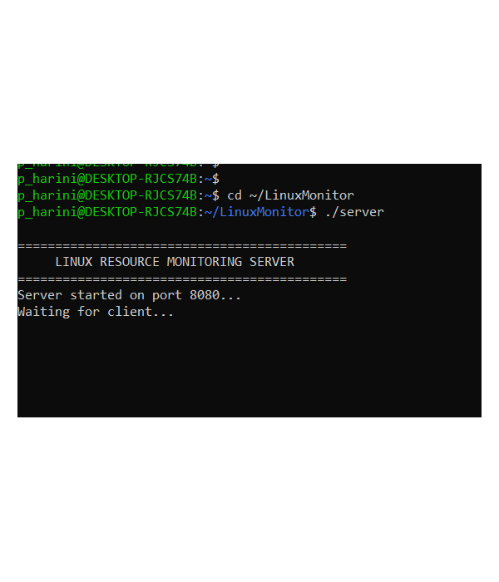
Figure 7.1 – Server started and listening on port 8080
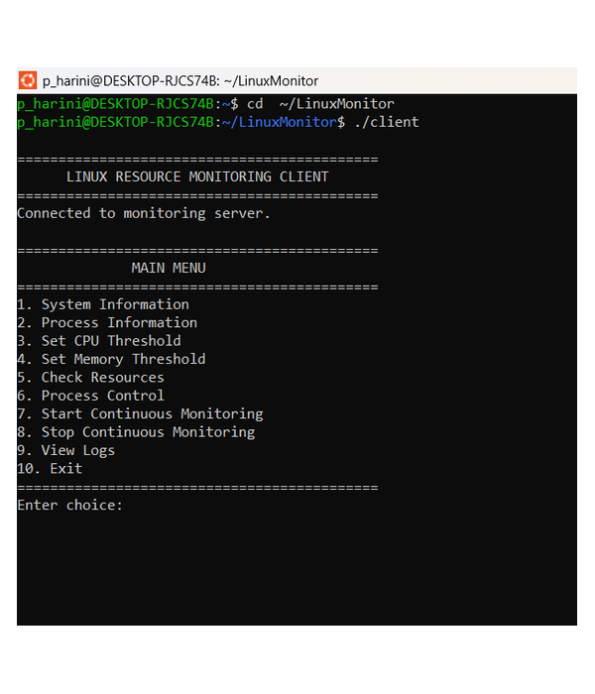
Figure 7.2 – Client connected to the server – main menu
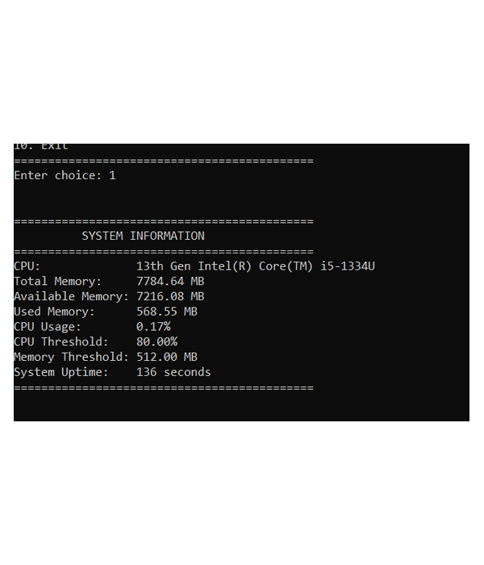
Figure 7.3 – System information (option 1)
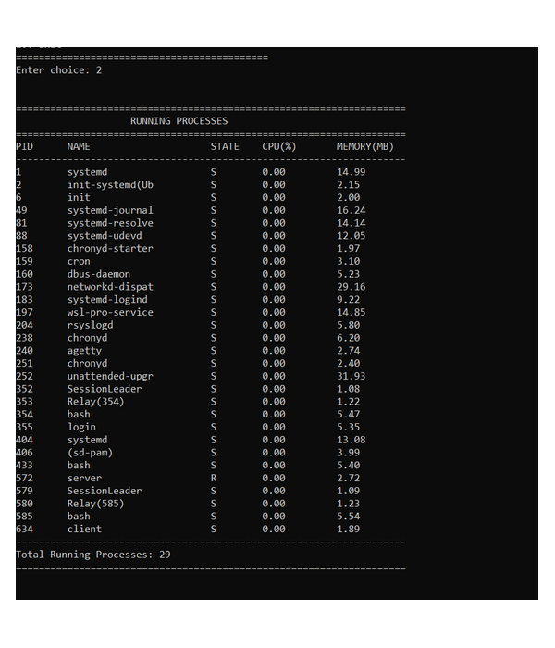
Figure 7.4 – Process information (option 2)
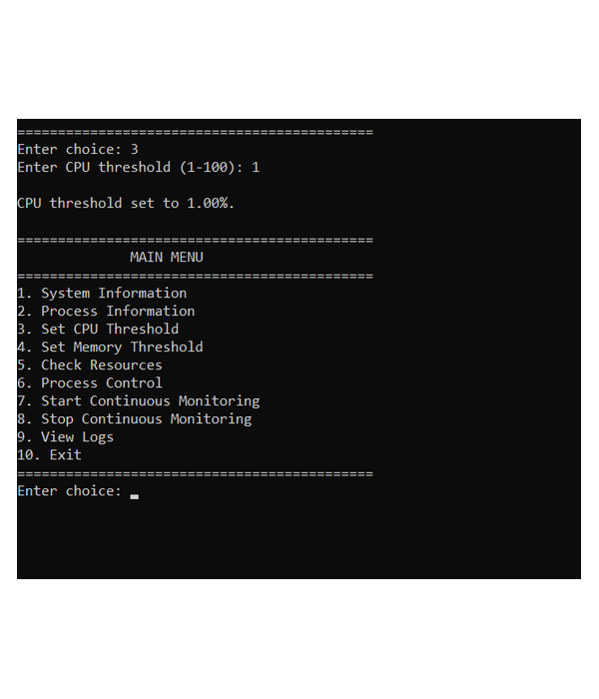
Figure 7.5 – Setting the CPU threshold (option 3)
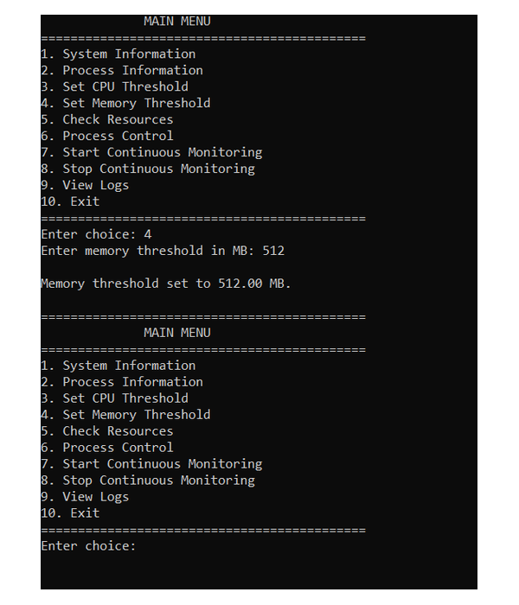
Figure 7.6 – Setting the memory threshold (option 4)
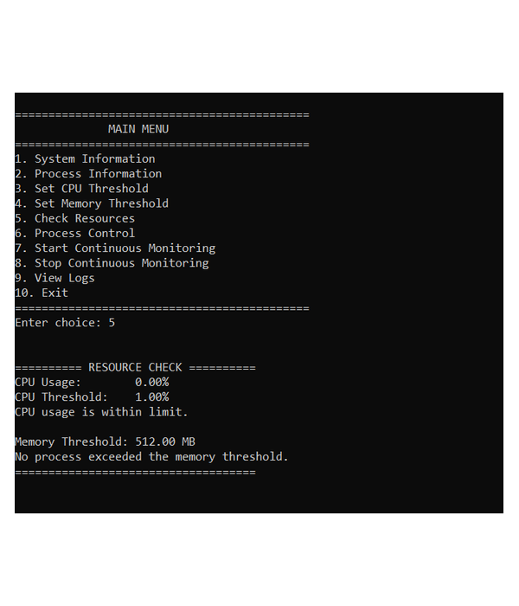
Figure 7.7 – Resource check (option 5)
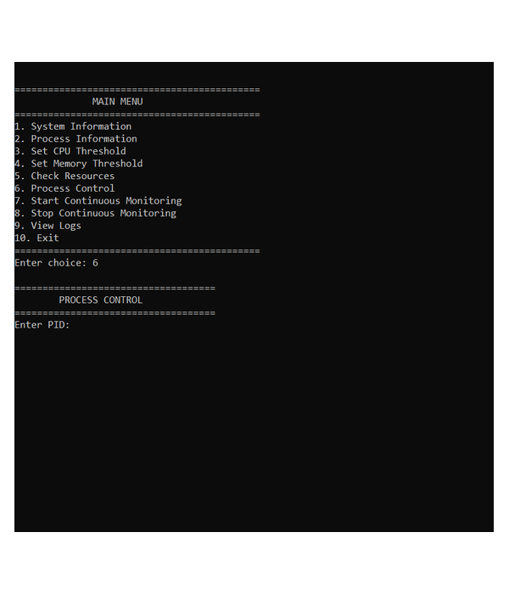
Figure 7.8 – Process control – PID prompt (option 6)
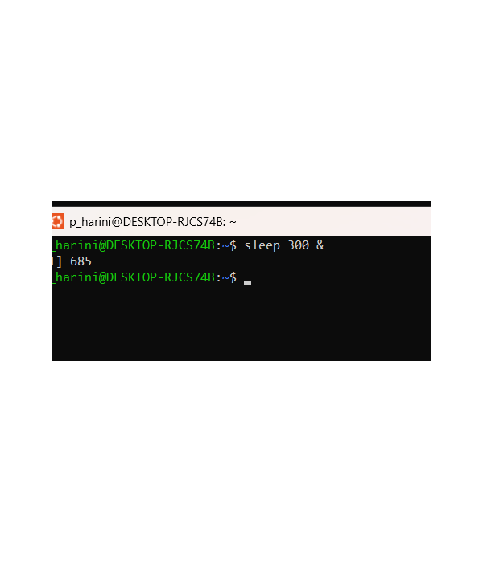
Figure 7.9 – Test process started with sleep 300 &
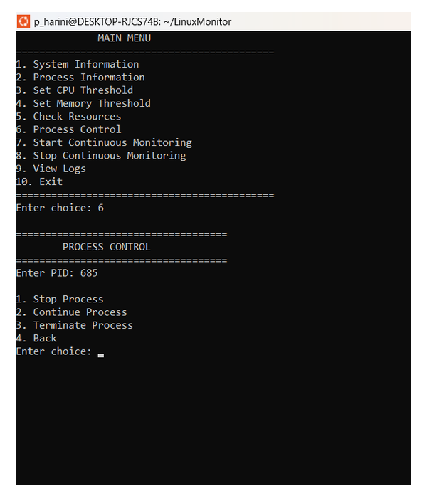
Figure 7.10 – Process control menu for the test process
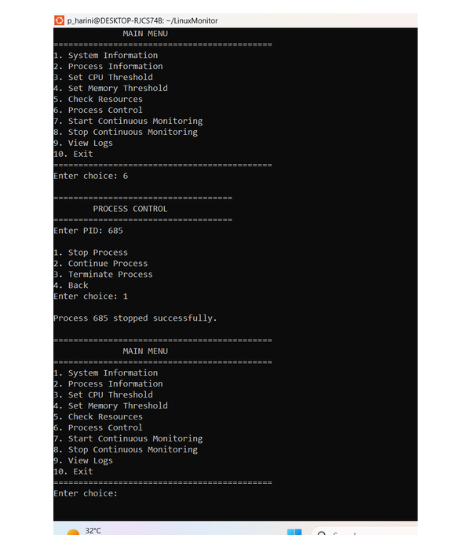
Figure 7.11 – Process stopped (SIGSTOP)
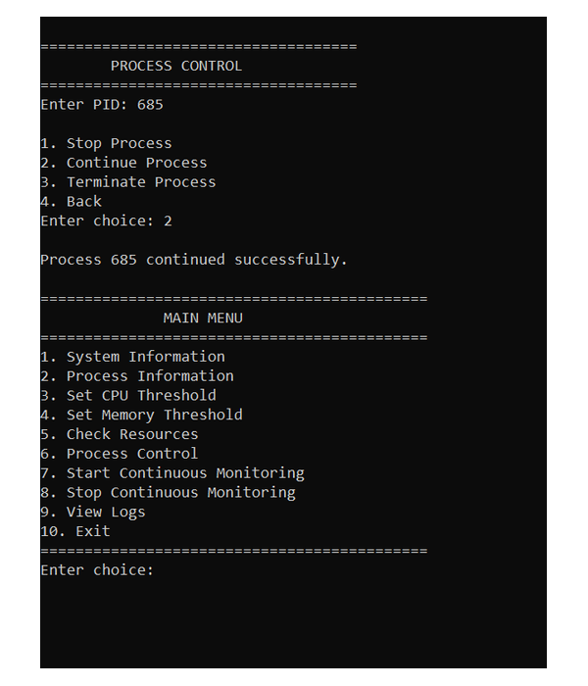
Figure 7.12 – Process continued (SIGCONT)
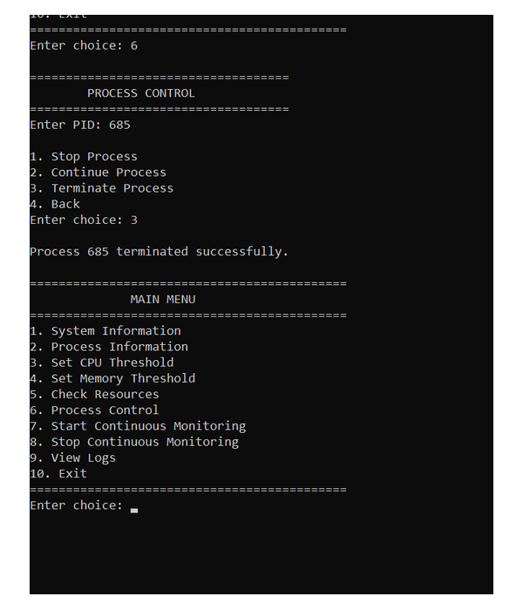
Figure 7.13 – Process terminated (SIGTERM)
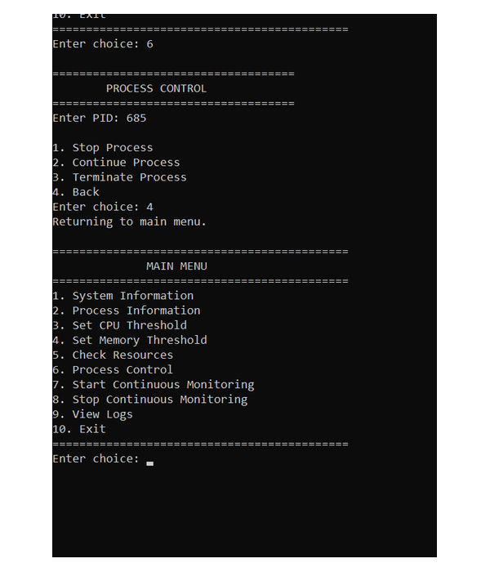
Figure 7.14 – Process control – Back to the main menu
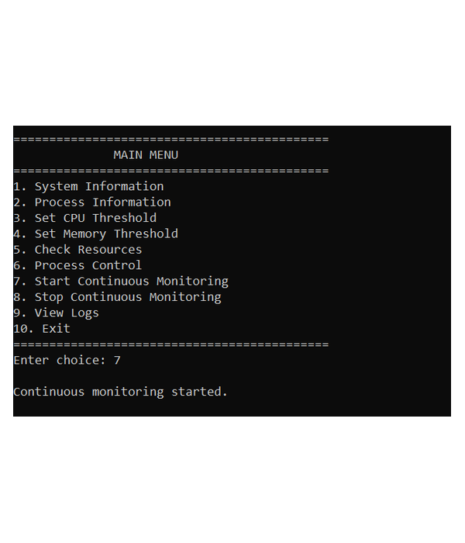
Figure 7.15 – Continuous monitoring started (option 7)
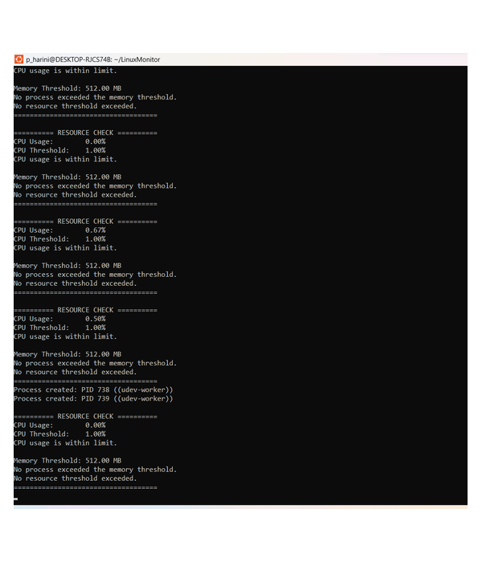
Figure 7.16 – Resource status during continuous monitoring
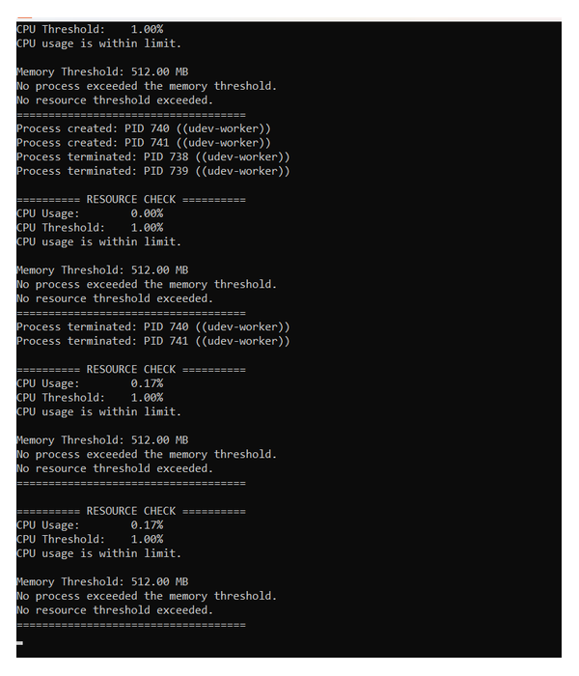
Figure 7.17 – Process creation and termination reported during monitoring
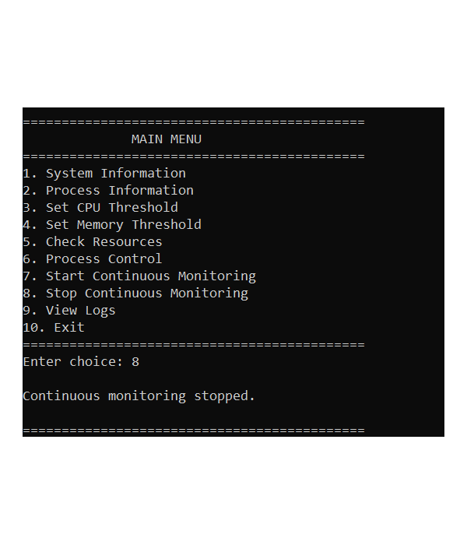
Figure 7.18 – Continuous monitoring stopped (option 8)
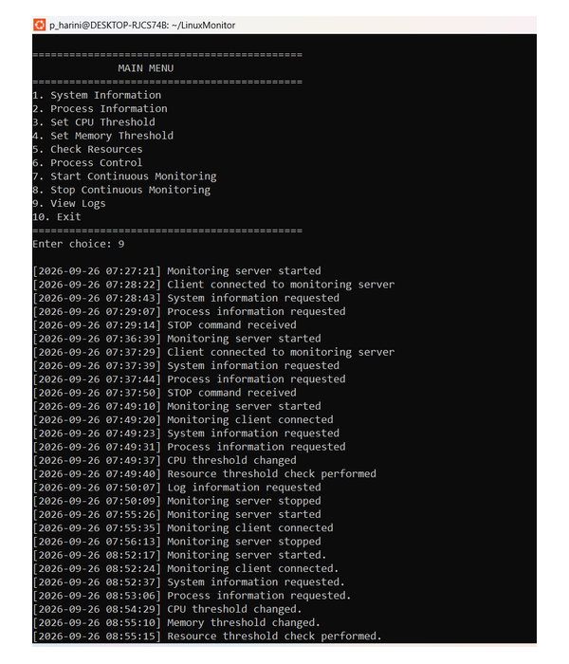
Figure 7.19 – View logs (option 9)
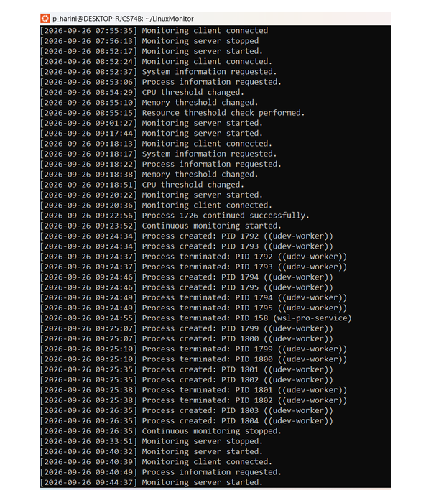
Figure 7.20 – Log file details
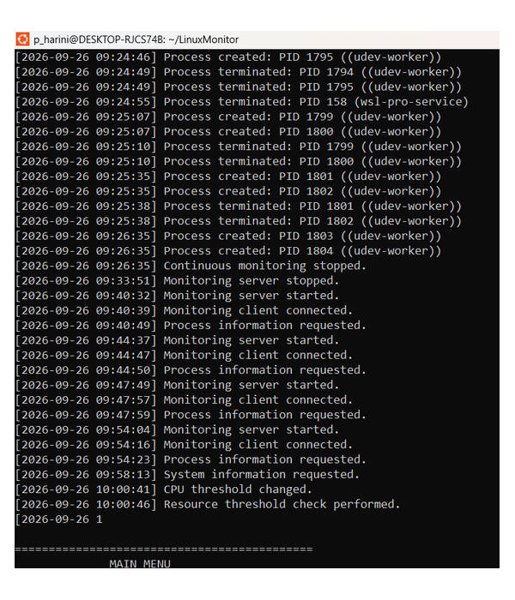
Figure 7.21 – Monitoring log output
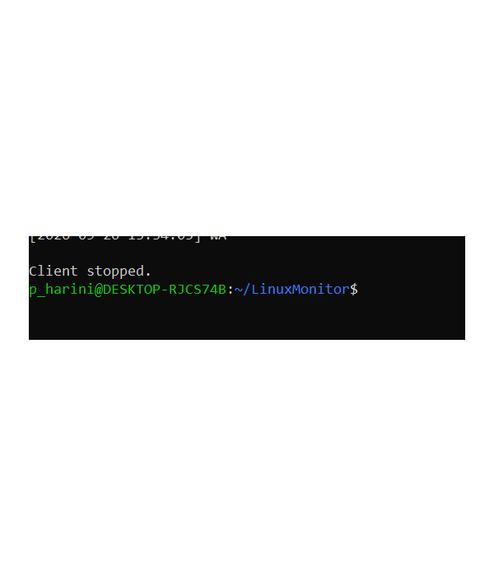
Figure 7.22 – Exit (option 10)

7.5 Demonstration of OS Concepts
OS concept | Where it is demonstrated
/proc filesystem | System information and process information (options 1 and 2)
Process states | State column in the process list; stopped state after SIGSTOP
Signals | Process control (option 6) with SIGSTOP, SIGCONT and SIGTERM
Threads | Continuous monitoring (options 7 and 8)
Sockets (client-server) | Every menu operation travels from client to server over TCP port 8080
File I/O | Writing and reading logs/monitor.log (option 9)
System calls | kill(), statvfs(), sysinfo(), socket calls, file calls

CHAPTER -8 CONCLUSION

8.1 Summary of the Project
The Linux System Information and Resource Monitoring Tool is a C-based system programming project that monitors Linux system resources and running processes through a command-line client. It obtains data from the /proc filesystem and other Linux interfaces, supports configurable CPU and memory thresholds with warnings, controls processes through signals, tracks process creation and termination using a POSIX thread, and records important activity in a log file. The client and the monitoring server communicate over TCP sockets on port 8080, and detailed listings are shown on the server terminal.

8.2 Objectives Achieved
- Running processes and their states are monitored and displayed.
- CPU, memory, disk and uptime information is collected from /proc and system interfaces.
- CPU and memory thresholds can be configured and warnings are generated.
- Processes can be stopped, continued or terminated by PID using signals.
- Newly created and terminated processes are tracked during continuous monitoring.
- Monitoring activities are logged and can be viewed through the client menu (the log is printed on the server terminal).
- Client-server communication over TCP sockets and POSIX-thread based monitoring are implemented.

8.3 Results Achieved
The project delivers a working monitoring tool with a ten-option menu covering system information, process information, threshold configuration, resource checking, process control, continuous monitoring, log viewing and exit. It demonstrates practical application of Operating Systems concepts in a single integrated program. The current version has the following limitations, which are planned as future improvements:
- Per-process CPU percentage is not calculated; processes are listed with state and memory usage only.
- Shared data (thresholds, the stored process list and the monitoring flag) is not protected by mutexes.
- The server serves one client at a time and assumes that each received message is one complete command.
- The logs directory must be created before the server is started.
- Detailed listings (options 1, 2, 5, 9 and monitoring output) are displayed on the server terminal rather than sent to the client.

8.4 Skills and Learning Outcomes
- Reading and interpreting kernel data from the /proc filesystem.
- Process states and process control with Linux signals.
- Multithreaded programming with POSIX threads.
- Network programming with TCP sockets in a client-server design.
- File I/O for logging, and use of system calls such as kill() and statvfs().
- Building with GCC and make, version control with Git/GitHub, and team-based testing and integration.

CHAPTER -9 REFERENCES

9.1 Books
- A. Silberschatz, P. B. Galvin and G. Gagne, Operating System Concepts, 10th ed., Wiley, 2018.
- M. Kerrisk, The Linux Programming Interface, No Starch Press, 2010.
- W. R. Stevens and S. A. Rago, Advanced Programming in the UNIX Environment, 3rd ed., Addison-Wesley, 2013.
- W. R. Stevens, B. Fenner and A. M. Rudoff, UNIX Network Programming, Volume 1: The Sockets Networking API, 3rd ed., Addison-Wesley, 2003.
- B. W. Kernighan and D. M. Ritchie, The C Programming Language, 2nd ed., Prentice Hall, 1988.

9.2 Research Papers
No research papers were used; the project is based on the textbooks and Linux documentation listed in this chapter.

9.3 Linux / GNU Documentation
- Linux manual pages: proc(5), signal(7), kill(2), statvfs(3), pthreads(7), socket(7) and tcp(7).
- GCC, the GNU Compiler Collection – online documentation.
- GNU Make Manual.

9.4 Online Resources
- Linux manual pages online: https://man7.org/linux/man-pages/
- The /proc filesystem, Linux kernel documentation: https://www.kernel.org/doc/html/latest/filesystems/proc.html
- Project repository: https://github.com/pakalapatiharini/-Linux-Process-Resource-Monitoring-System

